✴

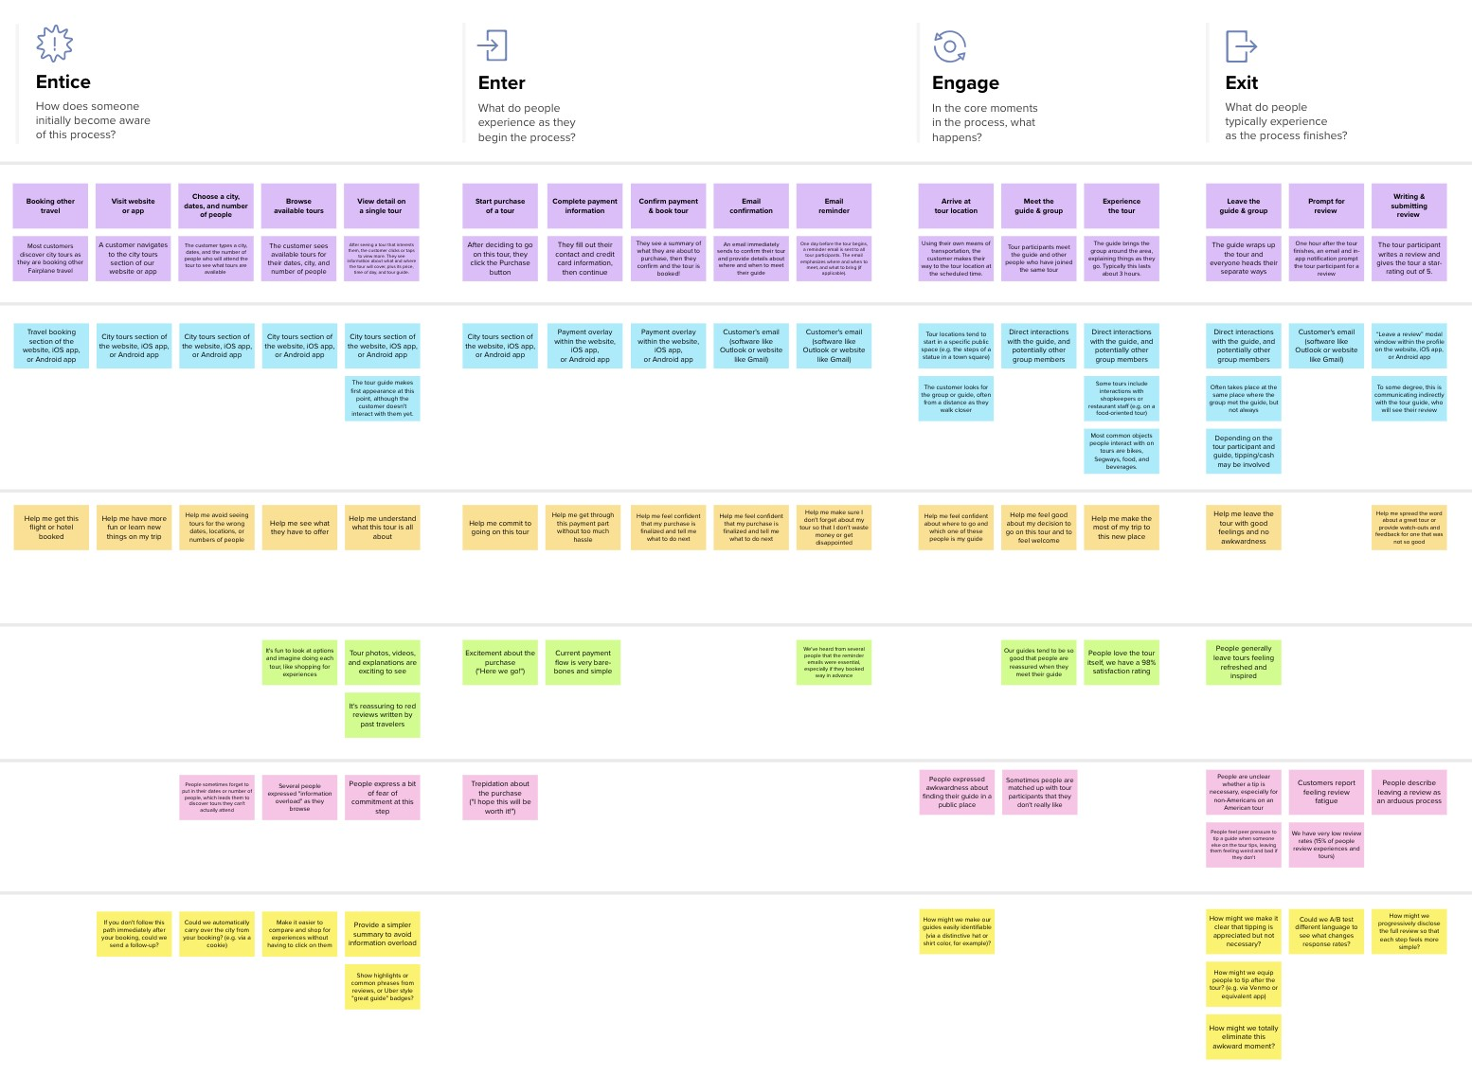

**Template**



**Document an existing experience**

**TIP**

As you add steps to the experience, move each these “Five Es” the left or right depending on the scenario you are documenting.

Narrow your focus to a specific scenario or process within an existing product or service. In the **Steps** row, document the step-by-step process someone typically experiences, then add detail to each of the other rows.

Customer experience journey map

|  |  |  |  |  |  |
| --- | --- | --- | --- | --- | --- |
| **SCENARIO**  **Browsing, booking, attending, and rating a local city tour** | **Entice**  How does someone initially become aware of this process? | **Enter**  What do people experience as they begin the process? | **Engage**  In the core moments in the process, what happens? | **Exit**  What do people typically experience  as the process finishes? | **Extend**  What happens after the experience is over? |
| **Steps**  What does the person (or group) typically experience? | **from friends from website**  Eagerness to Gain interest in  implement in their trying out the  own forms technology | **featurs of**  **login the**  **website**  they can find  login with various  username and features available in  emailid the website | **alert about alert about information control of climatic presence about moister motor**  **content of the**  **change of animals soil pump** | **huge loss precaution**  **will be measures**  **avoided will be taken**  **appropriately** | farmers will have self satisfaction about the protection measures |
| **Interactions**  What interactions do they have at each step along the way?  **People:** Who do they see or talk to?  **Places:** Where are they?  **Things:** What digital touchpoints or physical objects would they use? | from field which have already implemented  from ads and the smart crop  compaings protection system  get knowledge from the farmers who has done earlier | **positive**  **information feedbacks**  **about demo from other farmers** | **gives the tells that**  **current whether the**  **climatic soil need**  **condition of water for the**  **that area day** | **there is an chat option for asking doubts** | **complete experience will give better knowledge about the system** |
| **Goals & motivations**  At each step, what is a person’s primary goal or motivation? (“Help me...” or “Help me avoid...”) | **help me to avoid the help me to avoid**  **damage caused by damage caused by**  **climatic change animal and birds** | **help me get more idea about the working of the system** | **appropriate financial**  **actions will losses will**  **be taken in be reduced**  **right time** | **better crop yield will be assured** | **the farmer have better confident about their crop protection** |
| **Positive moments**  What steps does a typical person find enjoyable, productive, fun, motivating, delightful, or exciting? | **predict the climatic changes and plan accordingly** | **more user friendly system** | **better accomplish**  **control over task in one**  **the field click** | **reduction in manual work** | **farmers work made easy** |
| **Negative moments**  What steps does a typical person find frustrating, confusing, angering, costly, or time-consuming? | **continuous and need basic**  **stable internet knowledge**  **connection needed about technology** | **delay in receiving conformation and otp** | **technical failure in equipment** | **learning process is little tought** | **additional support might be needed to handle the system** |
| **Areas of opportunity**  How might we make each step better? What ideas do we have? What have others suggested? | **spread awareness about the advantages of smart farmers** | **improve the security of details of the farmers** | **improve**  **the speed improve**  **of speed of**  **processing receiving**  **alerts** | **better control over large area** | inclusion of technology in agriculture is more advantegious |

Use this framework to better understand customer needs, motivations, and obstacles by illustrating a key scenario or process from start to finish.



When possible, use this map to document and summarize interviews and observations with real people rather than relying on your hunches or assumptions.



Created in partnership with



[**Share template feedback**](https://muralco.typeform.com/to/CiqaHVat?typeform-source=app.mural.co)

**Need some inspiration?**



See a finished version of this template to kickstart your work.

[**Open example**](https://app.mural.co/template/f59f644b-b4b4-47b5-9ed6-3a8c71ceb612/896b31fe-5597-40ef-9b06-3811a1a45ace)

|  |  |  |  |
| --- | --- | --- | --- |
|  |  |  |  |
|  |  |  |  |